***GE 23131 – Programming using C***

***LABORATORY MANUAL***

**NAME: KEERTHANA S**

**REGISTER NO: 240801161**

**YEAR: Ist year**

**BRANCH: ELECTRONICS AND**

**COMMUNICATION ENGINEERING**

**(ECE)**

**SECTION: C**

**SEMESTER: I**

**ACADEMIC YEAR: 2024-2025**

**WEEK:0**

**ALGORITHM AND FLOWCHART**

**WEEK:0**

**ROLL N0: 240801161**

**NAME: KEERTHANA S**

**QUESTION:1**

**CALCULATE AREA AND PERIMETER**

**Write an Algorithm and draw a Flowchart to Calculate the area and perimeter of a square.**

**ALGORITHM:**

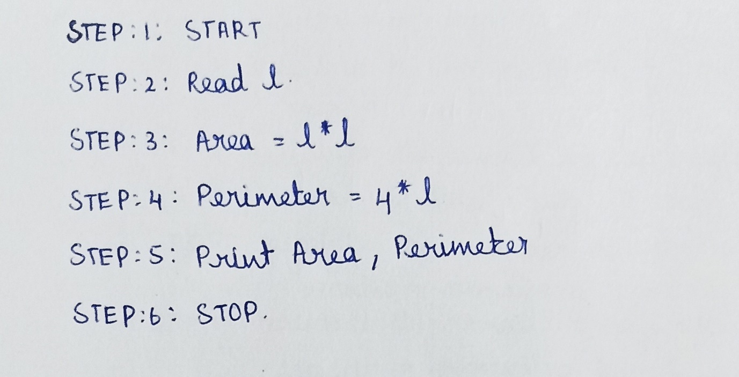

**FLOWCHART:**

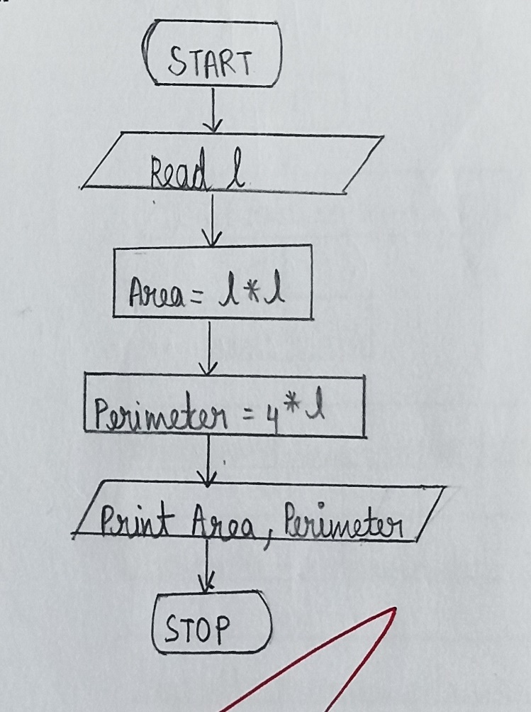

**QUESTION:2**

**DAYS TO YEAR CONVERSION**

**Write an Algorithm and draw a Flowchart to convert the given days into years & months.**

**ALGORITHM:**

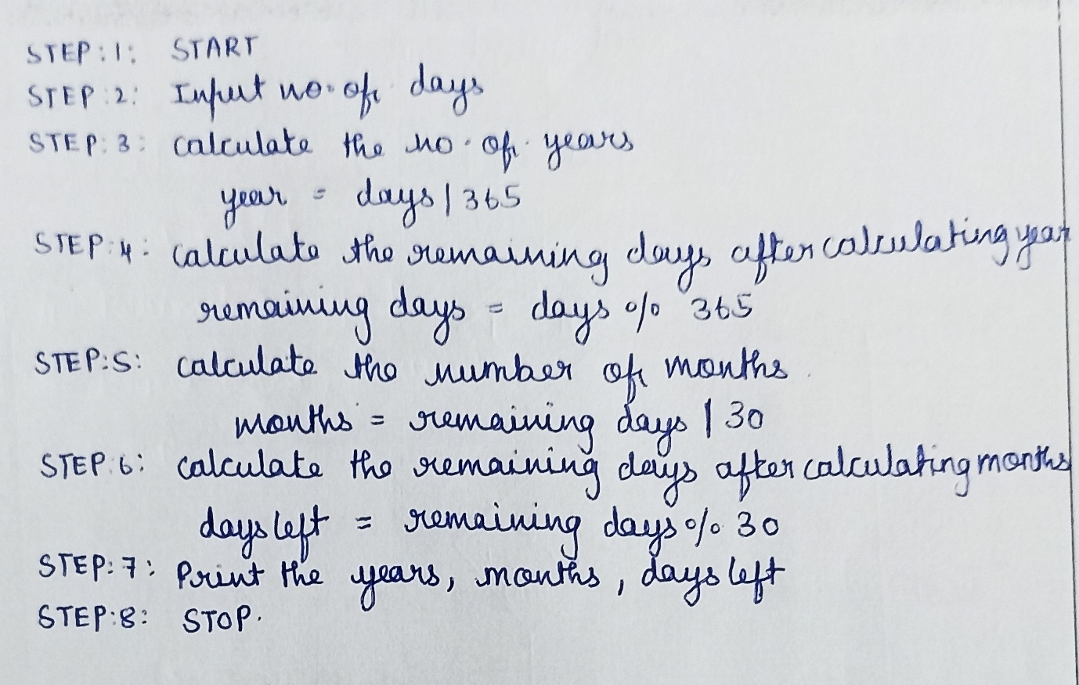

**FLOWCHART:**

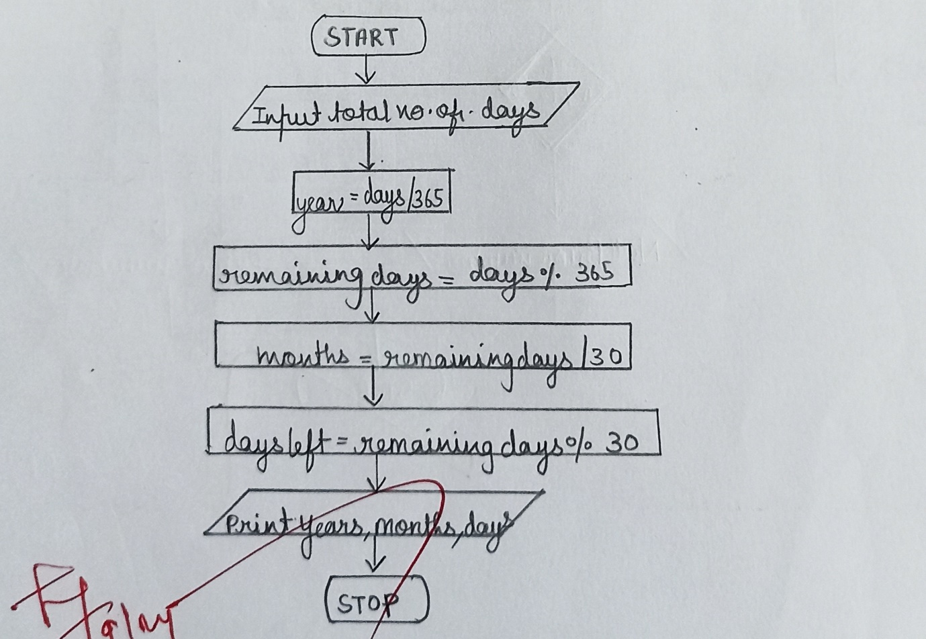

**QUESTION:3**

**PRIME NUMBER**

**Write an Algorithm and draw a Flowchart to check whether the given number is Prime or not.**

**ALGORITHM:**

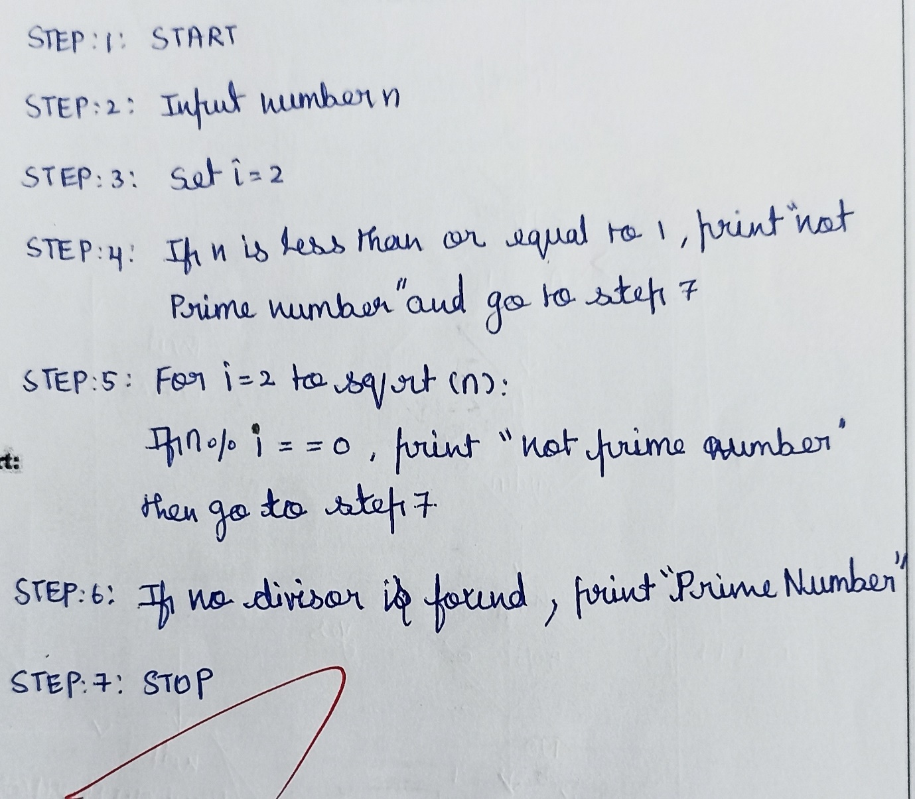

**FLOWCHART:**

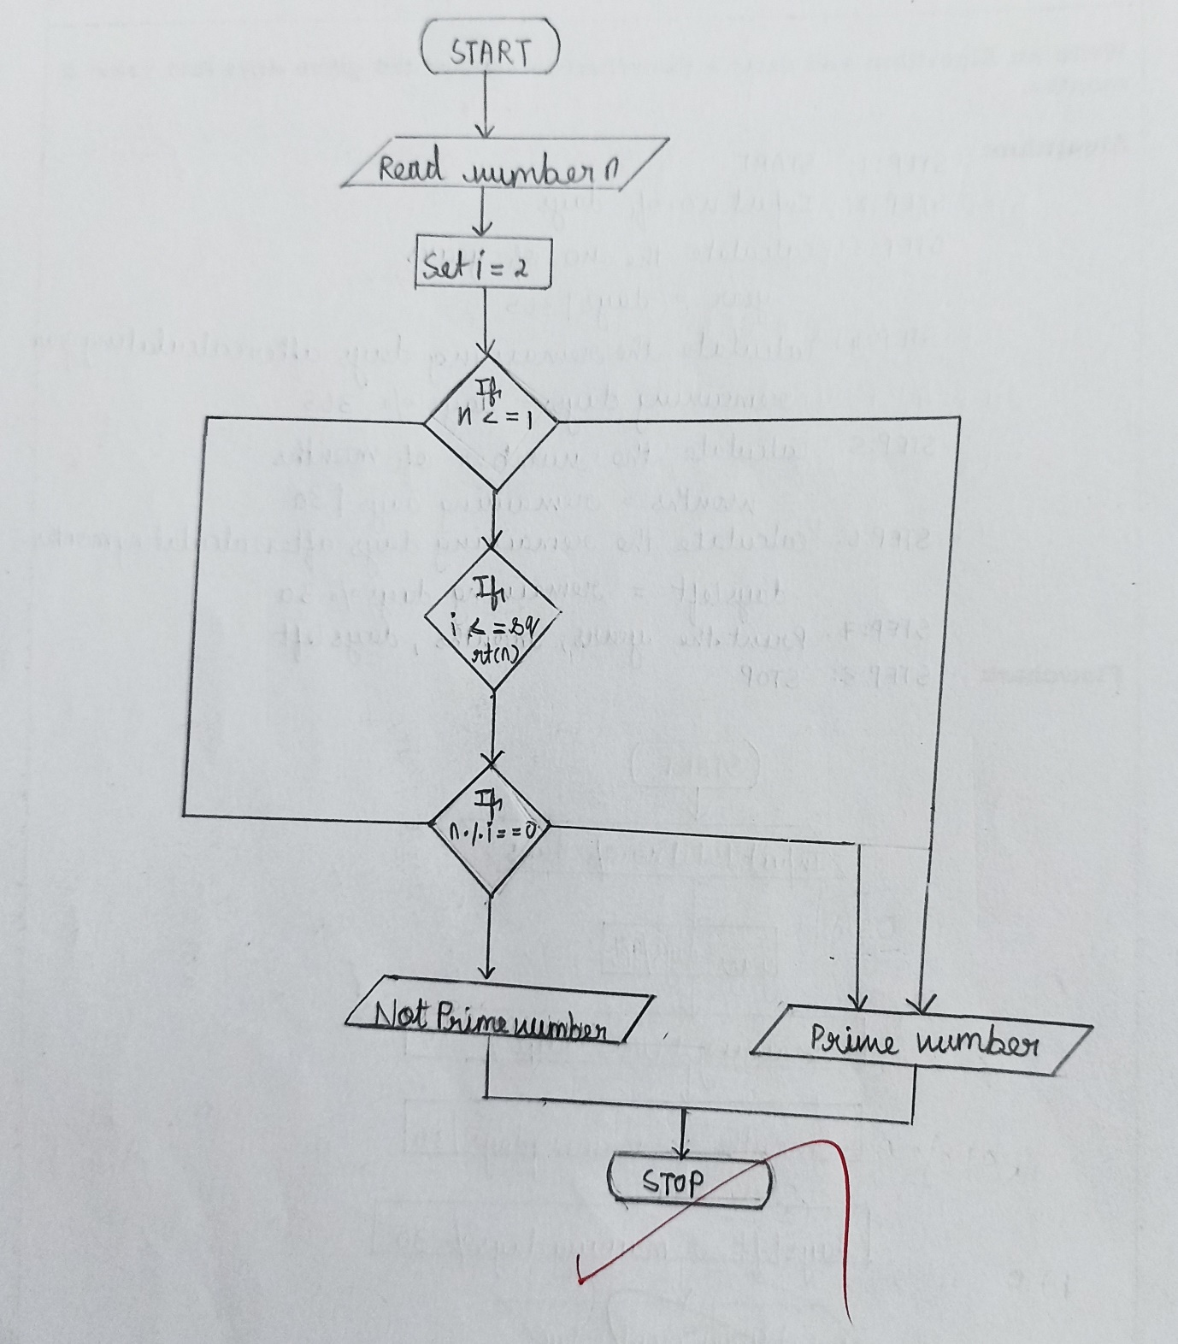

**QUESTION:4**

**LEAP YEAR**

**Write an Algorithm and draw a Flowchart to check whether the given year is Leap year or not.**

**ALGORITHM:**

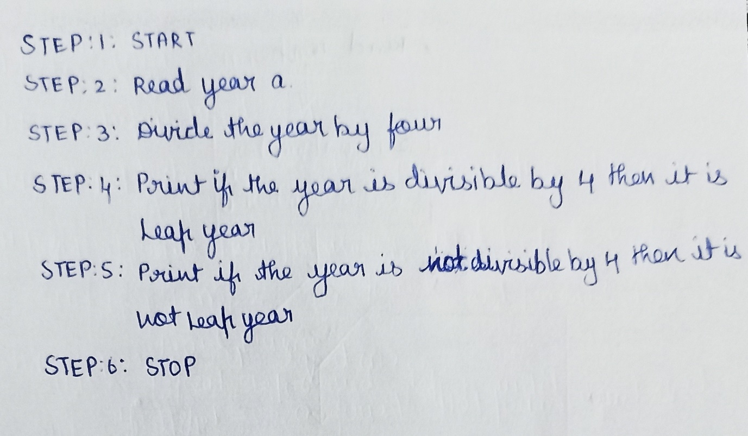

**FLOWCHART:**

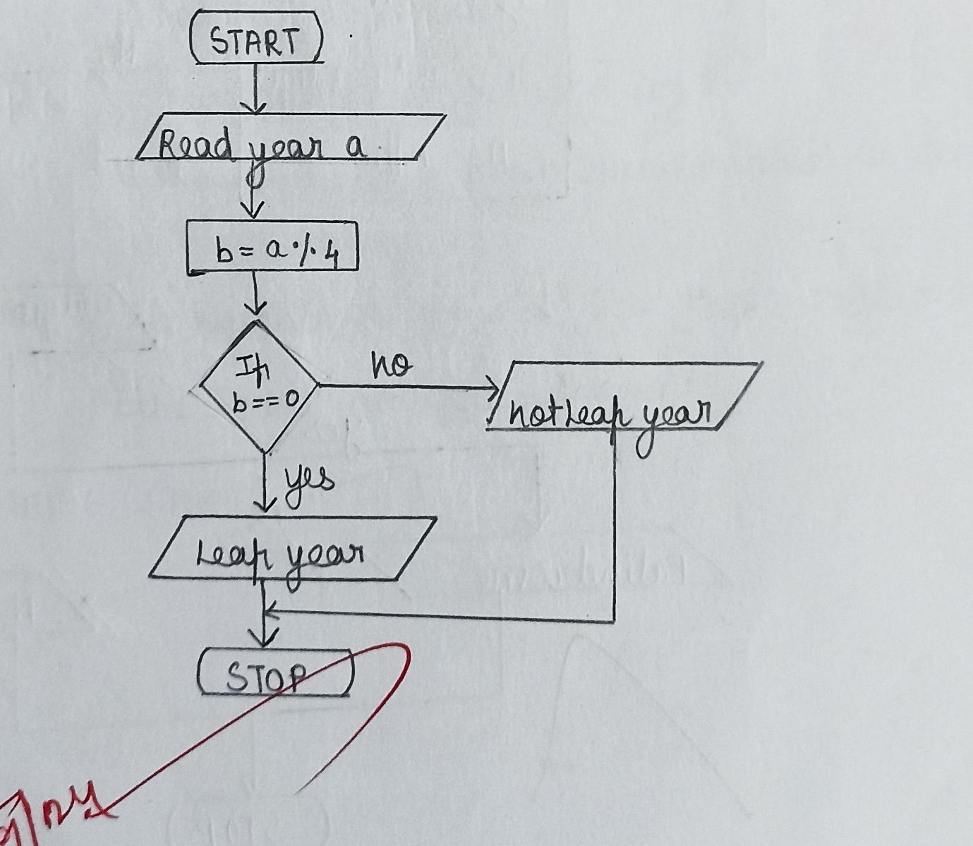

**QUESTION:5**

**PALINDROME NUMBER**

**Write an Algorithm and draw a Flowchart to check whether the given number is a palindrome number or not.**

**ALGORITHM:**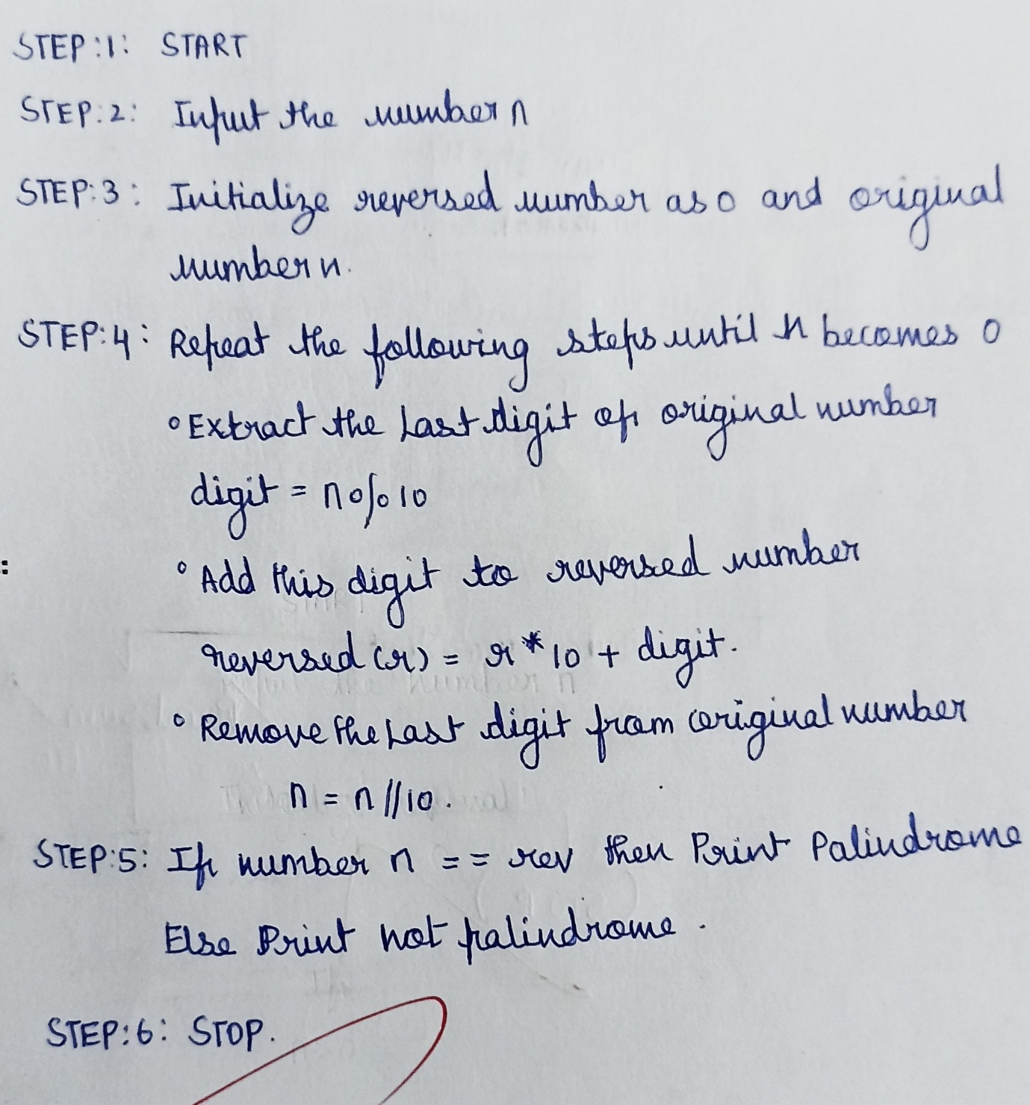

**FLOWCHART:**

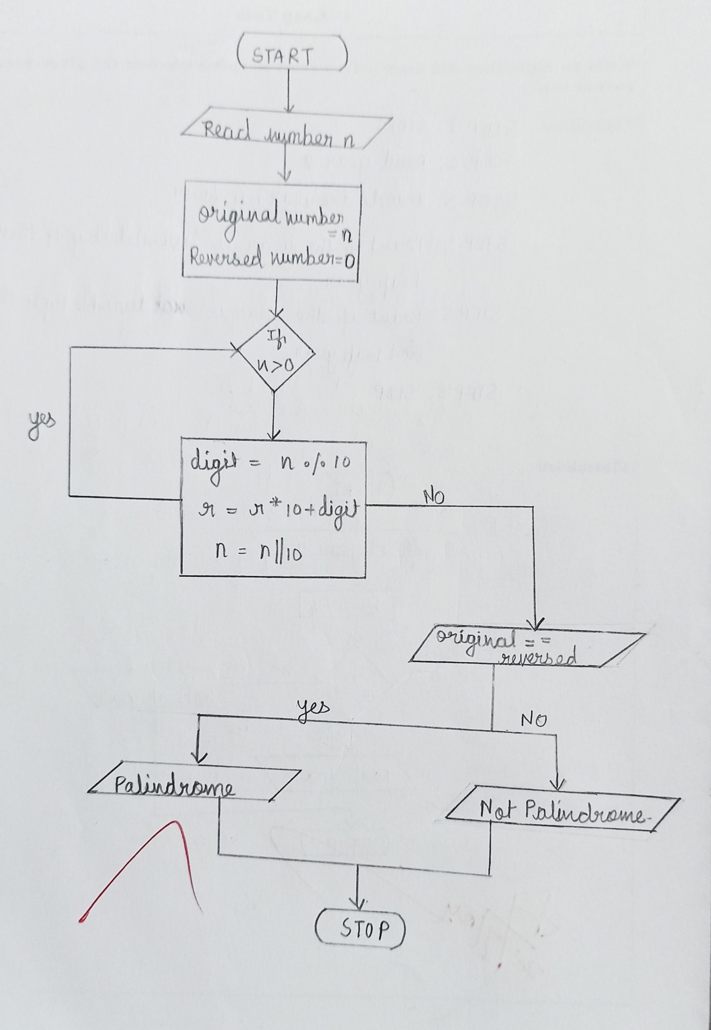

**QUESTION:6**

**SUM OF DIGITS**

**Write an Algorithm and draw a Flowchart to calculate the sum of digits in the given number.**

**ALGORITHM:**

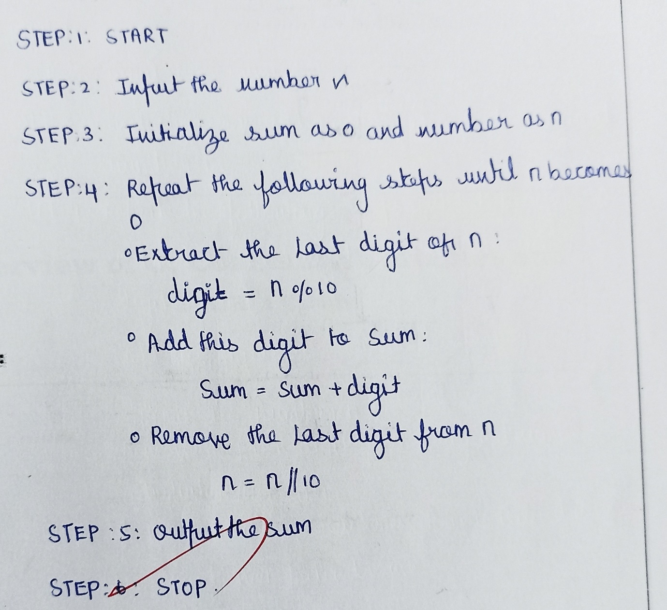

**FLOWCHART:**

